Page 1

Title: Database Design Appendix D Individual Assessment

Student Name: Prajjwal Rimal
Student id: c7466869

Page 2
- Introduction to the Report 3
- Task 1 Conceptual Design 4
- Task 2 Logical Design 8
- Task 3 Physical Design 10
- References 18
- AI declaration 20

Page 3
Introduction to the Report

This file includes the individual task that has been competed for one of the requirement of the 30% database systems module. Containing all 3 tasks related to the conceptual design stage, logical design stage and physical design stage.
The conceptual design stage consists of the EERD diagram generated by QSEE SuperLite which has been made by identifying the entities by using the entity identifying rules as discussed on the Fundamental of Database module during level 4.
Logical design consists of various tasks ranging from identifying the entity names, reverse logical design, finding the foreign keys based on EERD as well as normalization to the third normal form.
Finally, the Physical design stage consists of SQL implemented code in the APEX Oracle. This implementation was based on the scott table provided in our university blackboard link and implemented our understanding of basic SQL statements, creating tables, the use of union and join statements & vertical and horizontal partitioning.

Page 4

Task 1: Conceptual Design

1.
Each holiday package is provided for a certain number of customers. Each holiday package is categorized as being of a specific type e.g. Beach, Winter Sun, Skiing and Adventure, each of which have specific, unique requirements. Each package will fall into one of two journey types, either
• Return flight to a single destination
• Return coach transport with two destinations.
Holidays may have a courier, although some do not. Where group bookings are made the company needs to record information about the member of the group who is the Group leader, i.e. the arranger of the holiday.

Nouns:
- Holiday Package
- Customers
- Beach
- Winter Sun
- Skiing
- Adventure
- Journey Types
- Return Flight
- Return Coach
- Destination
- Courier
- Group Booking
- Company
- Group Leader

2 &3.
Rules used to determine entities:
- The object should be important to the system
- There should be attributes that can be associated with entity
- More than one occurrence of the entity
- It should not be an attribute of the entity

Entity name: HOLIDAY PACKAGES
Attribute | packageID | bookingID | courierID | type | price | Customers_count
Occurrence | Hp1 | Boo1 | Cou1 | beach | 35,000 | 3
Occurrence | Hp2 | Boo2 | - | Skiing | 15,000 | 7
Occurrence | Hp3 | Boo3 | Cou2 | adventure | 30,000 | 4
Entity name: BEACH
Attribute | packageID | destination_name
Occurrence | Hp1 | Maldives
Occurrence
Entity name: WINTER SUN
Attribute | packageID | destination_name
Occurrence
Occurrence
Entity name: SKIING
Attribute | packageID | destination_name
Occurrence | Hp2 | Canada
Occurrence
Entity name: ADVENTURE
Attribute | packageID | destination_name
Occurrence | Hp3 | Brazil
Occurrence
Entity name: CUSTOMERS
Attribute | customerID | bookingID | groupLeaderID | name | contactInfo | age | address
Occurrence | Cus1 | Boo1 | Cus1 | Arya Tamang | 9990001212 | 30 | Kathmandu
Occurrence | Cus2 | Boo2 | Cus4 | Bardan Rayamaji | 9863849211 | 78 | Toronto
Occurrence | Cus3 | Boo1 | Cus2 | Prajjwal Rimal | 9813643877 | 21 | Vancouver
Occurrence | Cus4 | Boo3 |  | Rivash Rijal | 9822791596 | 26 | India
Entity name: GROUP BOOKINGS
Attribute | bookingID | customerID | packageID | groupleaderName
Occurrence | Boo1 | Cus3 | Hp1 | Arya Tamang
Occurrence | Boo2 |  | Hp2 | Rivash Rijal
Occurrence | Boo3 |  | Hp3 | Bardan Rayamaji
Entity name: COURIER
Attribute | courierID | packageID | comapnyName | address
Occurrence | Cou1 | Hp1 | DHL | Sao Paulo
Occurrence | Cou2 | Hp2 | FEDEX | Quebec
Entity name: RETURN FLIGHT
Attribute | flightID | packageID | flightCabin | destinations
Occurrence | Fi1 | Hp3 | Business | Sao Paulo
Occurrence
Entity name: RETURN COACH
Attribute | coachID | packageID | coachBooking | destinations
Occurrence | Co1 | Hp1 | General | Quebec, Baffin Islands
Occurrence | Co2 | Hp2 | General | Toronto, Vancouver

4.
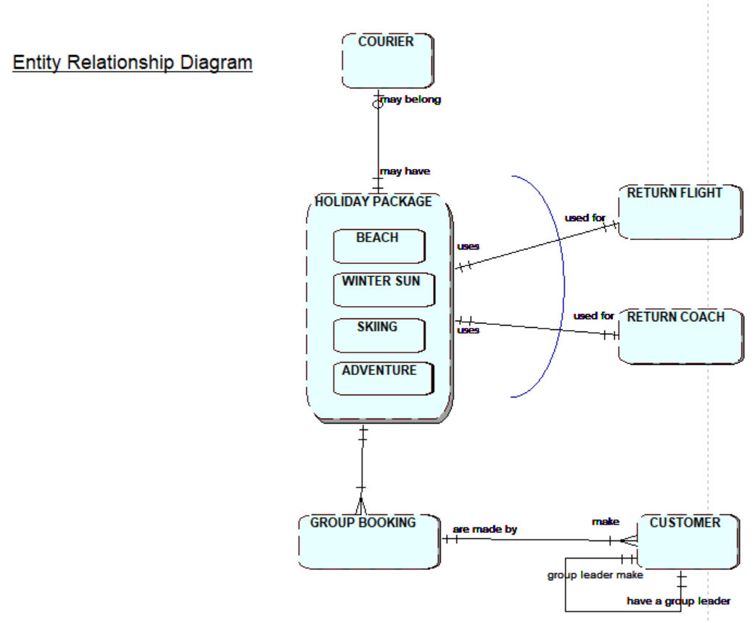

Task 2: Logical Design

A.
1.
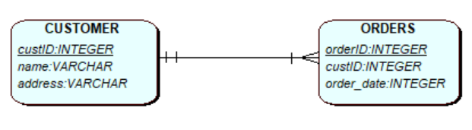
2.
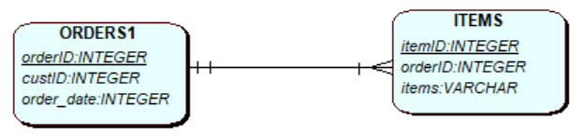
3.
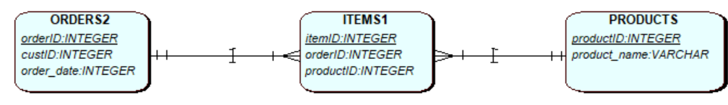
4.
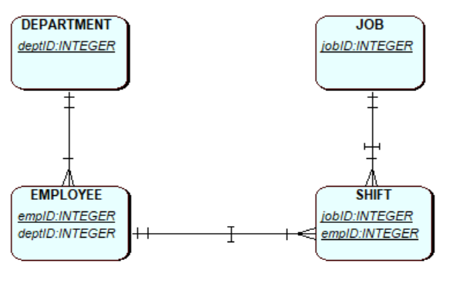
B.
Foreign key implemented by looking at the relationship cardinality
Task (Task_id, Task_Name)
Project (Project_id, Project_StartDate, Project_EndDate)
Project_Task (PT_id, Project_id, Consultant_id, Task_id, Desc)
Consultant (Consultant_id, Name, Address, Phone)
Appointment (Appointment_ref, Consultant_id, Client_id, Date, Location)
Client (Client_id, Name, Address, Phone)

C.
“1NF: each row and column contain one and only one value, identify primary keys
2NF: every non primary key attribute is fully functionally dependent on the primary key
3NF: no non primary key attribute is transitively dependent on the primary key” (thomas Connolly, n.d.)

1nf was wrong, and since 1nf was incorrect by extension 2nf and 3nf were also incorrect. In 1nf Idate was labeled as the primary key, however this is wrong as I day is not a concrete unique value, hence the placement of Staff no as the primary key as staff number is unique for every staff.
UNF | 1NF | 2NF | 3NF
Property No. | Property No. | Property No. | Property No.
Property Addr. | Property Addr. | Property Addr | Property Addr
Idate*
Itime* | PropertyNo. | Property No. | Property No.
Comment* | Staff_no | Staff_no | Staff_no
Staff_no* | Itime | Idate | Idate
Sname* | Comment | Itime | Itime
Car_reg* | Idate | Comment | Comment
 | Sname
 | Car_reg | Staff_no | Staff_no
 |  | Sname | Sname
 |  | Car_reg | Car_reg
Task 3: Physical Design

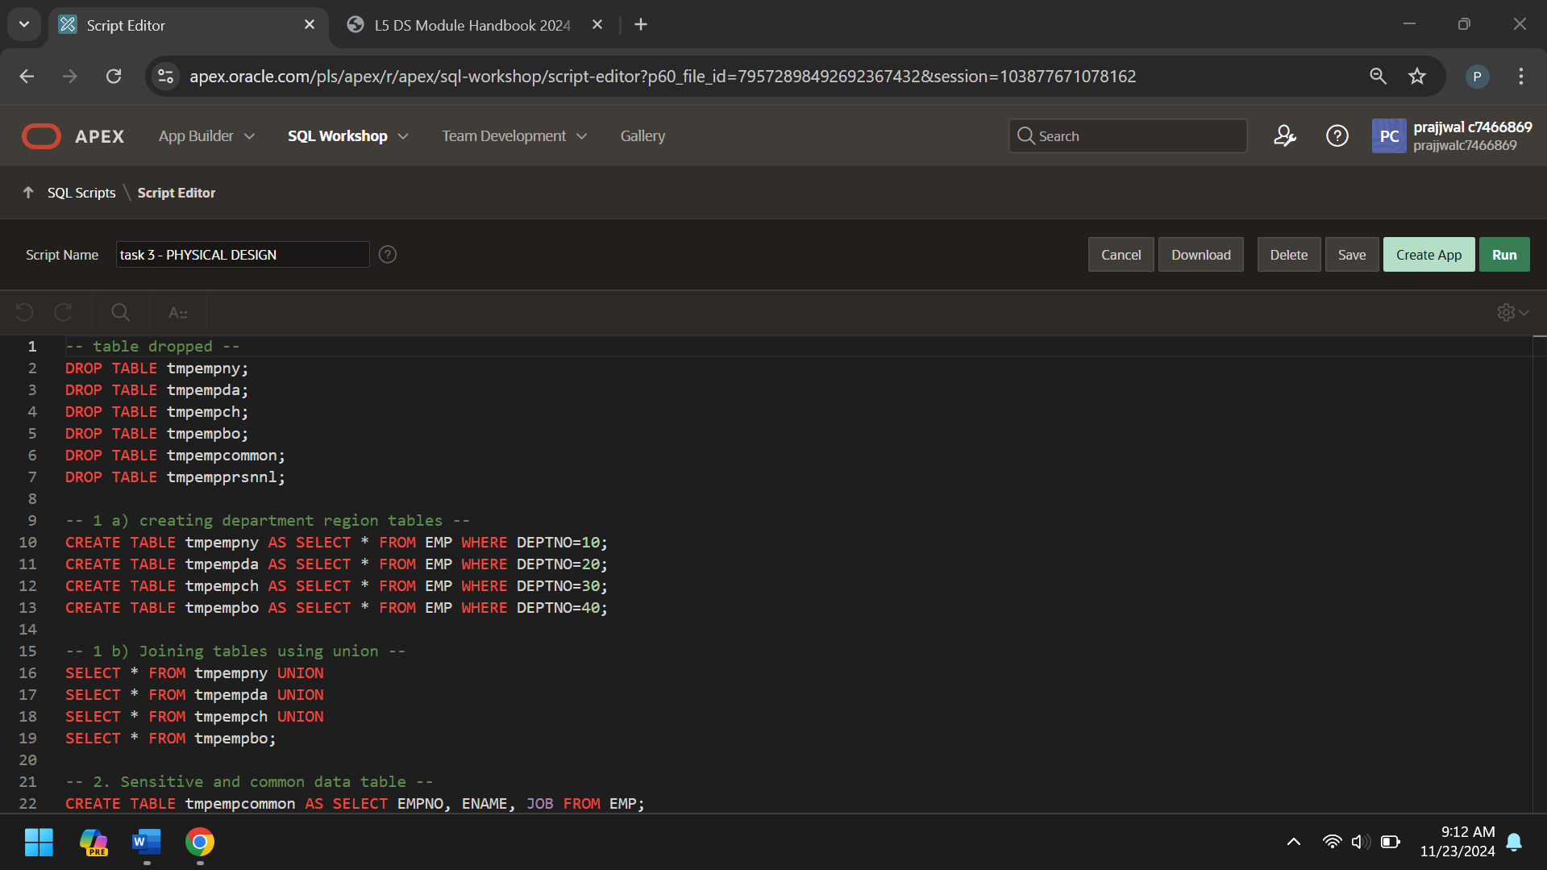
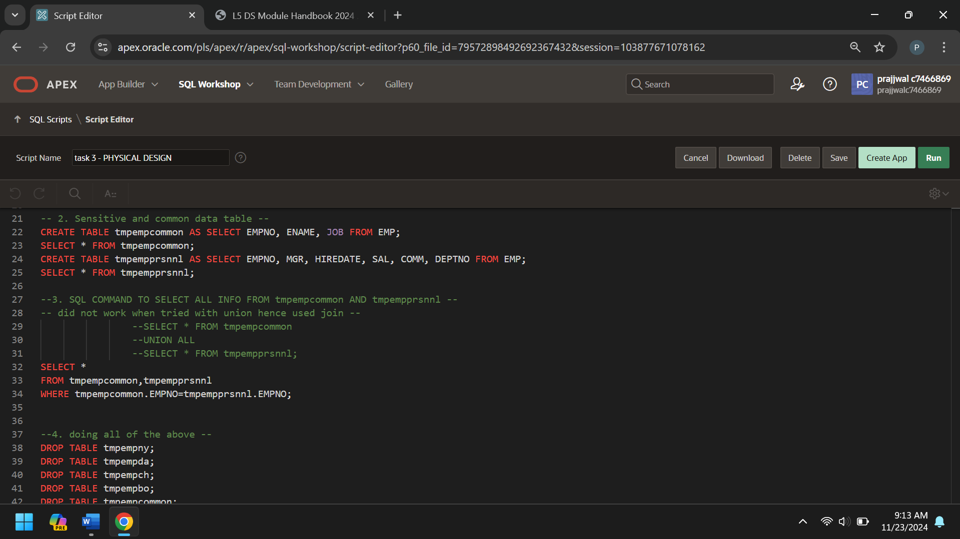
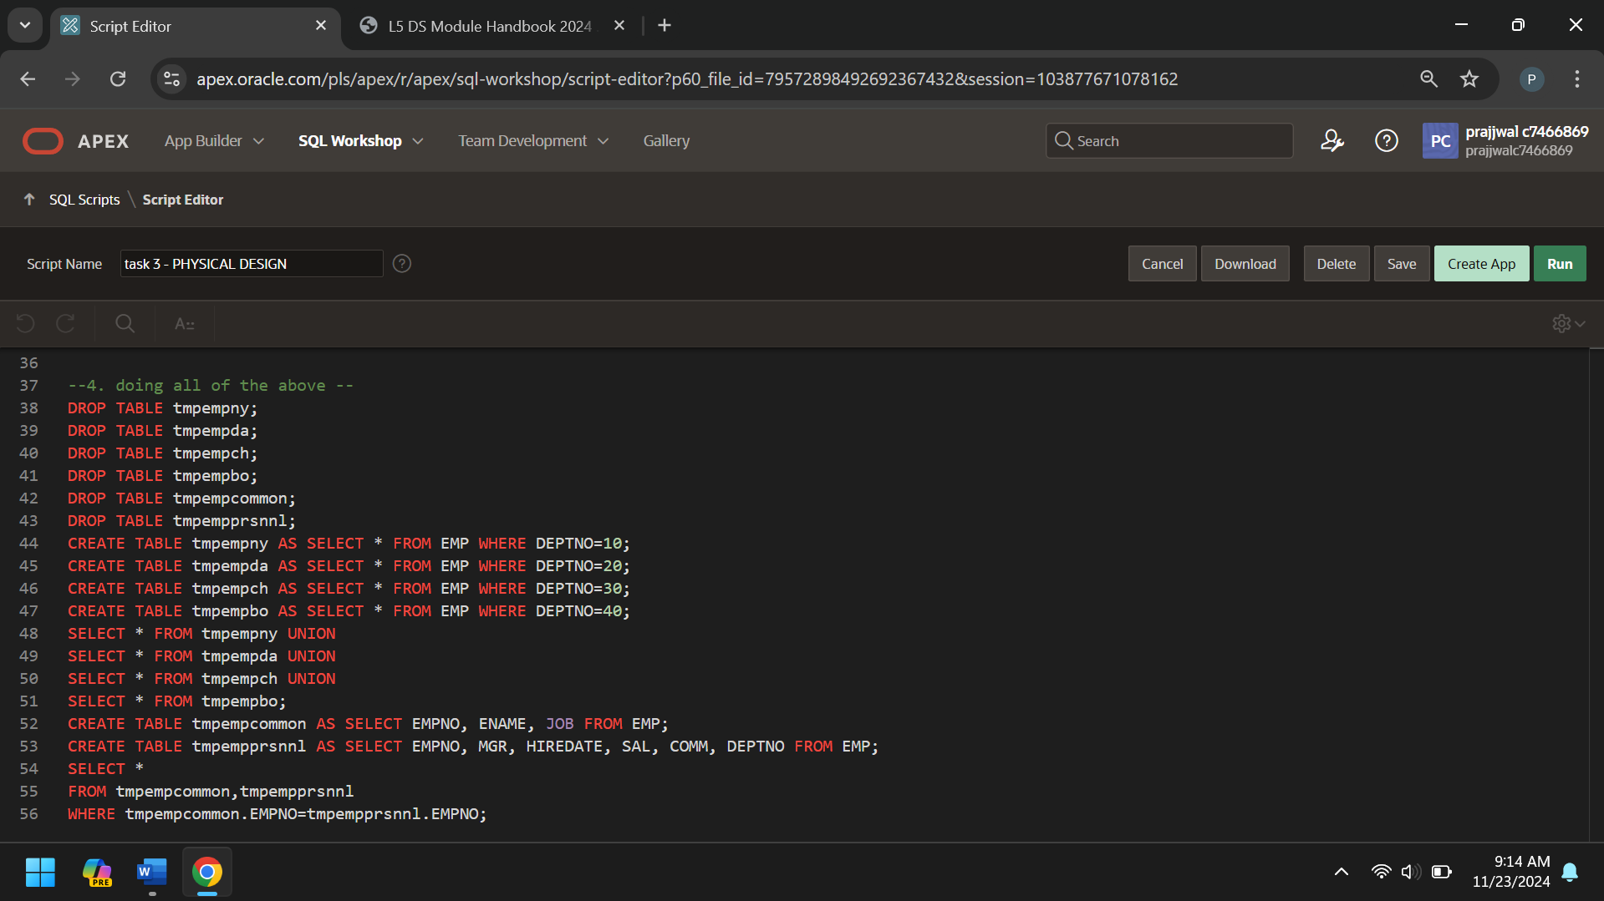

-- table dropped --
DROP TABLE tmpempny;
DROP TABLE tmpempda;
DROP TABLE tmpempch;
DROP TABLE tmpempbo;
DROP TABLE tmpempcommon;
DROP TABLE tmpempprsnnl;

-- 1 a) creating department region tables --
CREATE TABLE tmpempny AS SELECT * FROM EMP WHERE DEPTNO=10;
CREATE TABLE tmpempda AS SELECT * FROM EMP WHERE DEPTNO=20;
CREATE TABLE tmpempch AS SELECT * FROM EMP WHERE DEPTNO=30;
CREATE TABLE tmpempbo AS SELECT * FROM EMP WHERE DEPTNO=40;

-- 1 b) Joining tables using union --
SELECT * FROM tmpempny UNION
SELECT * FROM tmpempda UNION
SELECT * FROM tmpempch UNION
SELECT * FROM tmpempbo;

-- 2. Sensitive and common data table --
CREATE TABLE tmpempcommon AS SELECT EMPNO, ENAME, JOB FROM EMP;
SELECT * FROM tmpempcommon;
CREATE TABLE tmpempprsnnl AS SELECT EMPNO, MGR, HIREDATE, SAL, COMM, DEPTNO FROM EMP;
SELECT * FROM tmpempprsnnl;

--3. SQL COMMAND TO SELECT ALL INFO FROM tmpempcommon AND tmpempprsnnl --
-- did not work when tried with union hence used join --
--SELECT * FROM tmpempcommon
--UNION ALL
--SELECT * FROM tmpempprsnnl;
SELECT *
FROM tmpempcommon,tmpempprsnnl
WHERE tmpempcommon.EMPNO=tmpempprsnnl.EMPNO;

--4. doing all of the above --
DROP TABLE tmpempny;
DROP TABLE tmpempda;
DROP TABLE tmpempch;
DROP TABLE tmpempbo;
DROP TABLE tmpempcommon;
DROP TABLE tmpempprsnnl;
CREATE TABLE tmpempny AS SELECT * FROM EMP WHERE DEPTNO=10;
CREATE TABLE tmpempda AS SELECT * FROM EMP WHERE DEPTNO=20;
CREATE TABLE tmpempch AS SELECT * FROM EMP WHERE DEPTNO=30;
CREATE TABLE tmpempbo AS SELECT * FROM EMP WHERE DEPTNO=40;
SELECT * FROM tmpempny UNION
SELECT * FROM tmpempda UNION
SELECT * FROM tmpempch UNION
SELECT * FROM tmpempbo;
CREATE TABLE tmpempcommon AS SELECT EMPNO, ENAME, JOB FROM EMP;
CREATE TABLE tmpempprsnnl AS SELECT EMPNO, MGR, HIREDATE, SAL, COMM, DEPTNO FROM EMP;
SELECT *
FROM tmpempcommon,tmpempprsnnlr
WHERE tmpempcommon.EMPNO=tmpempprsnnl.EMPNO;

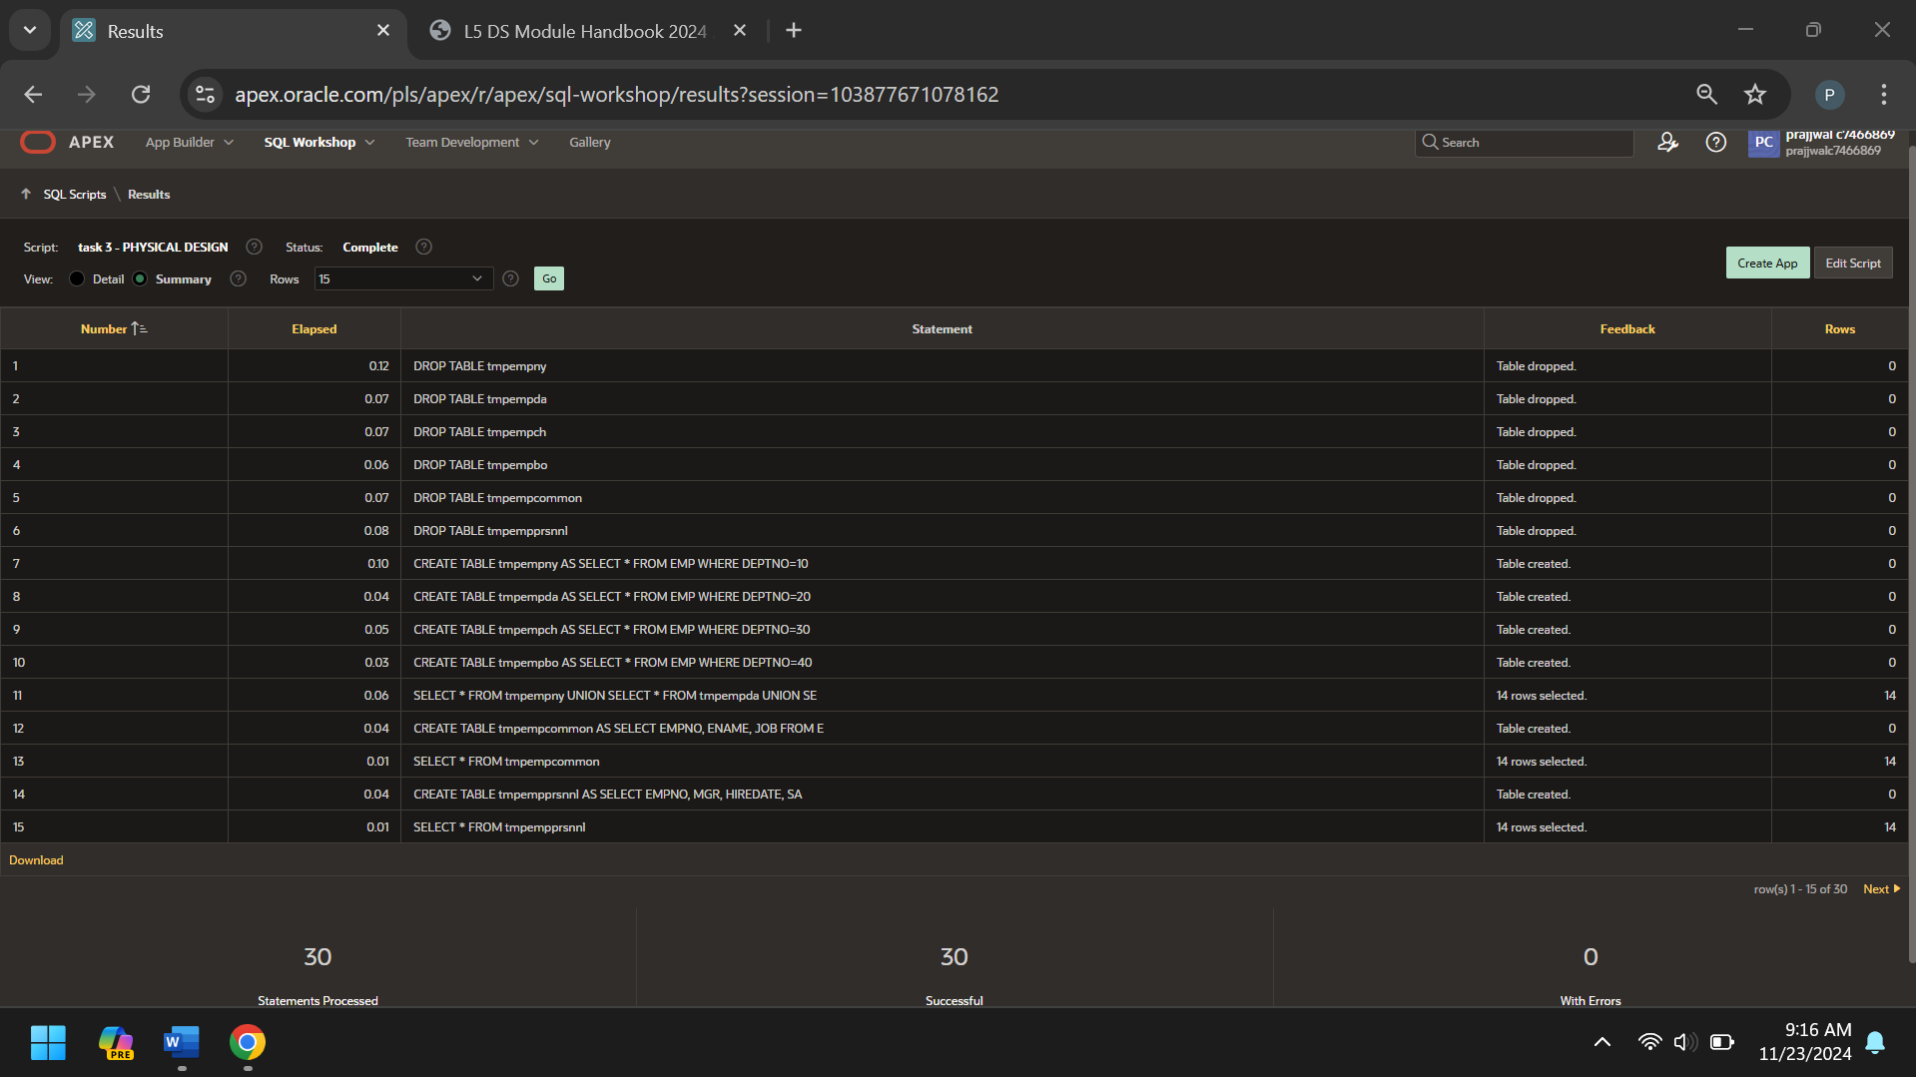
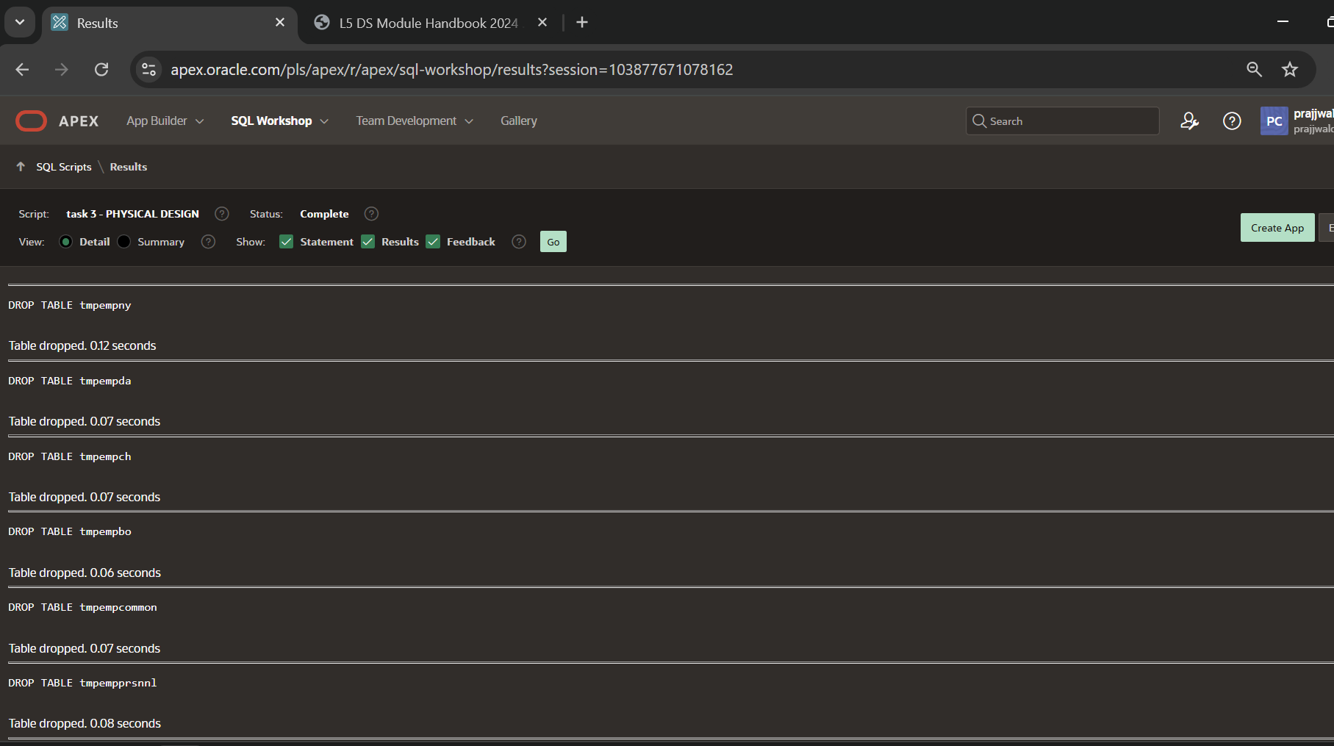
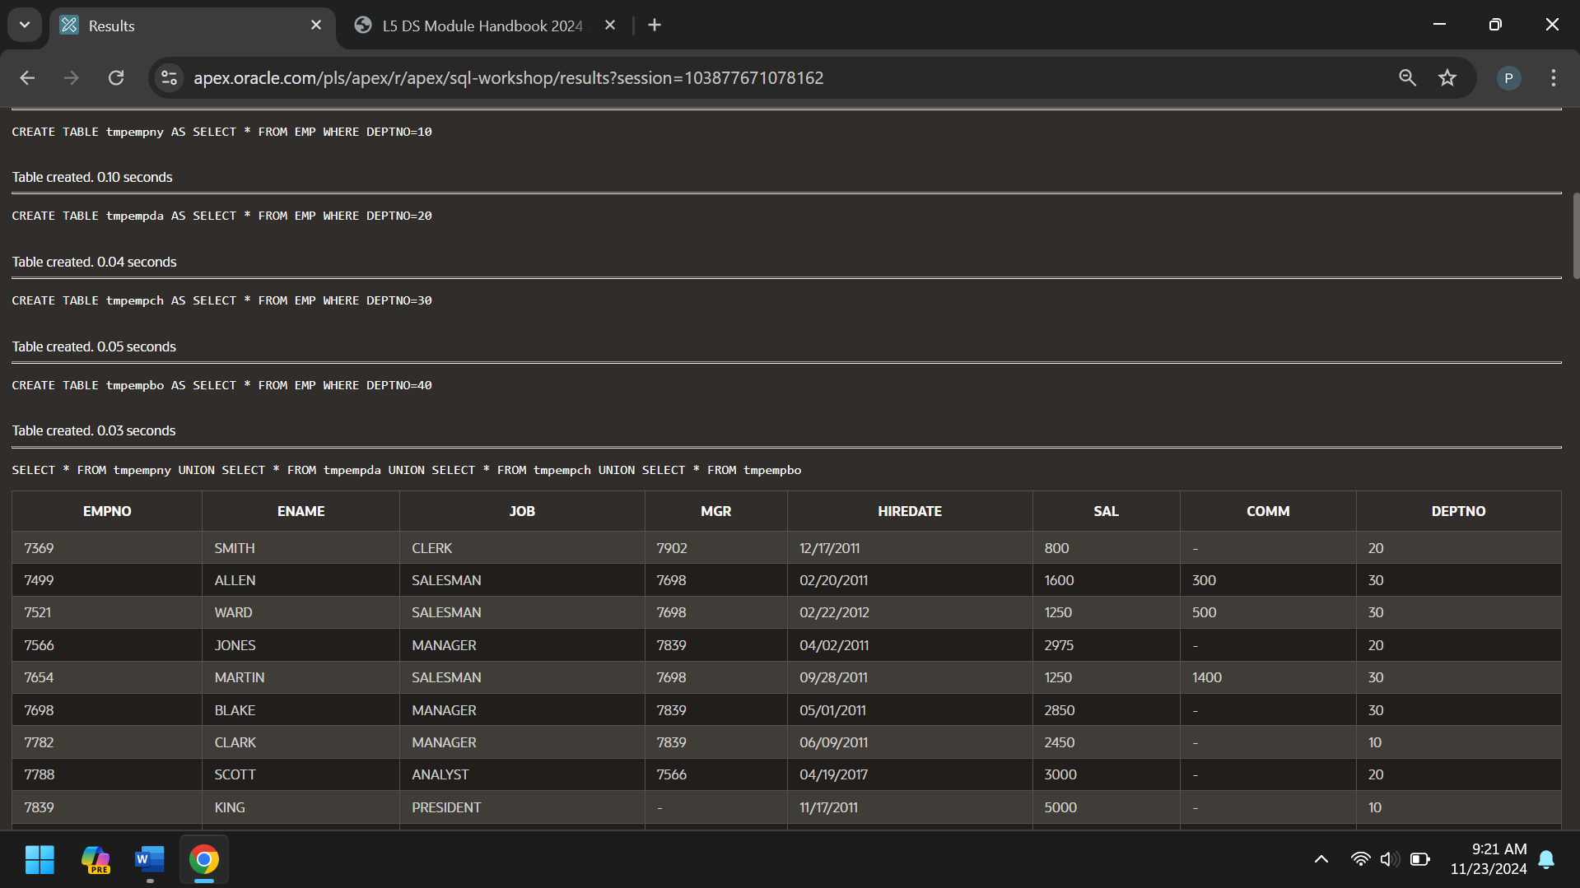
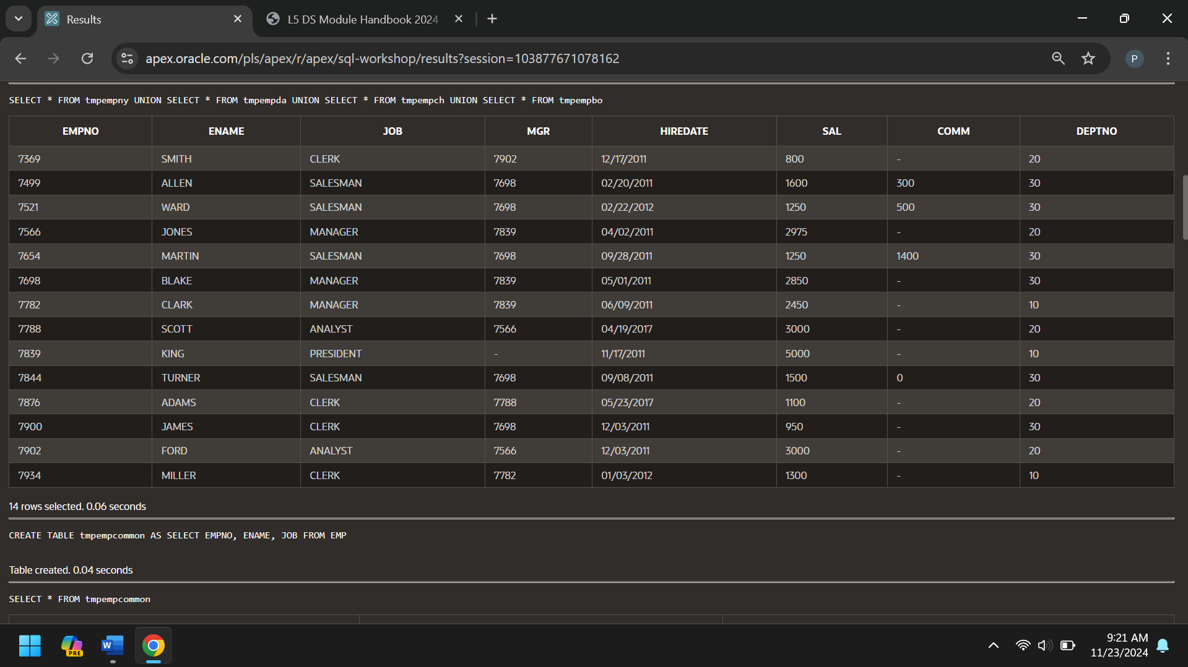
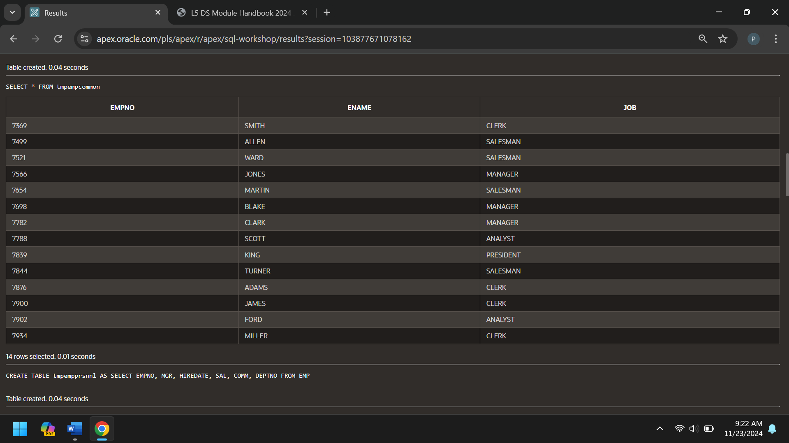
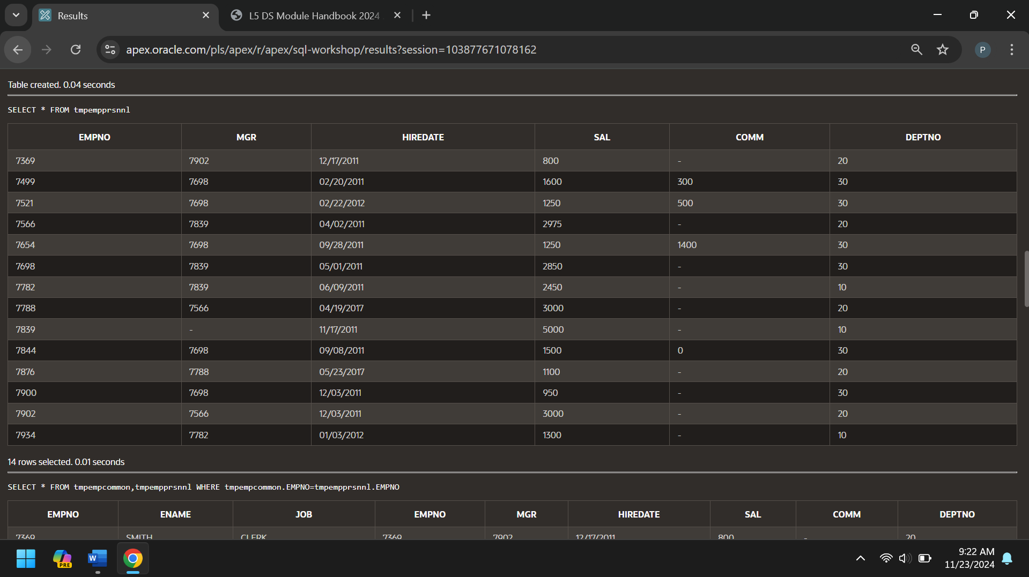
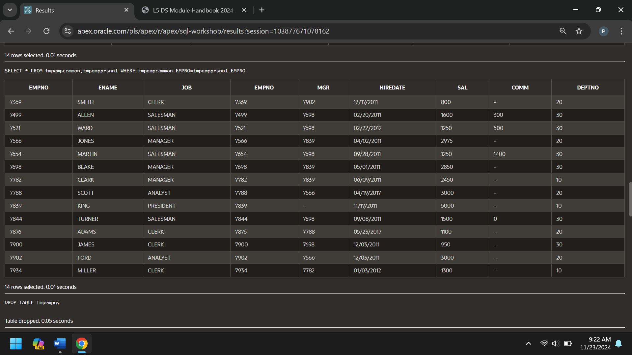
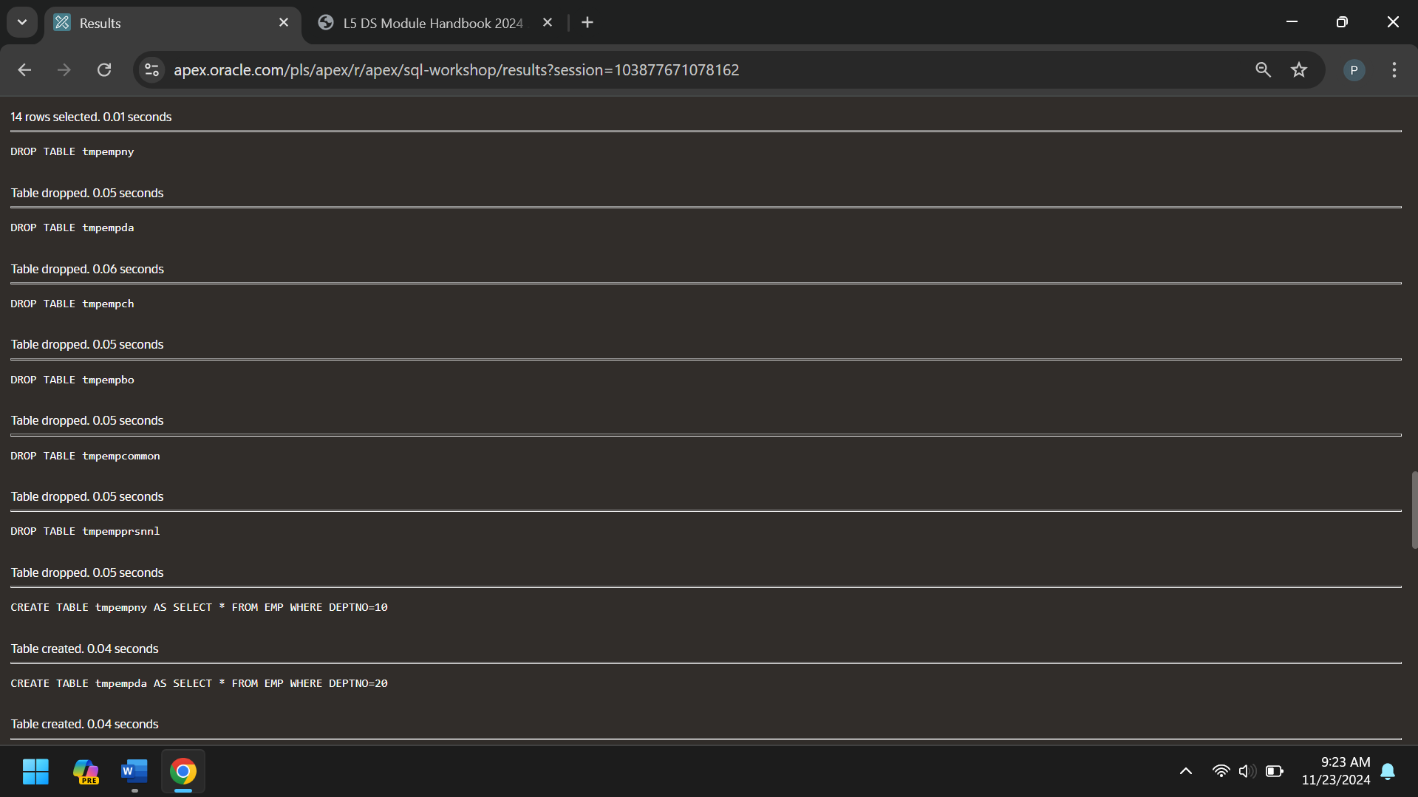
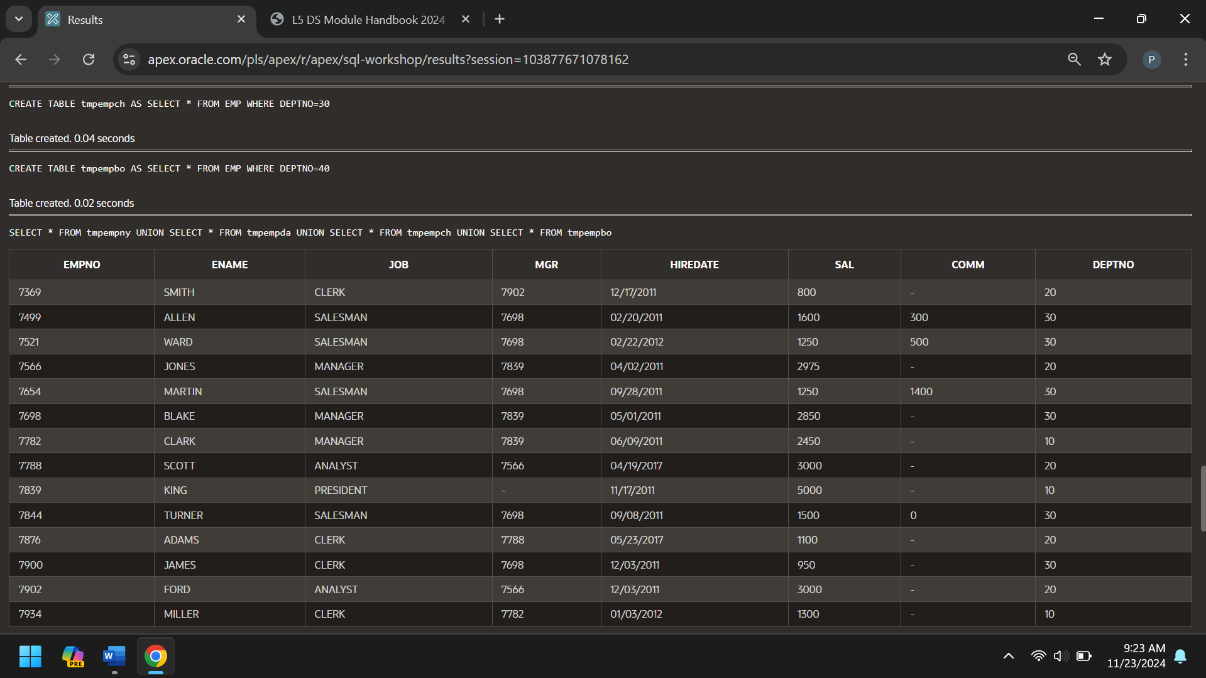
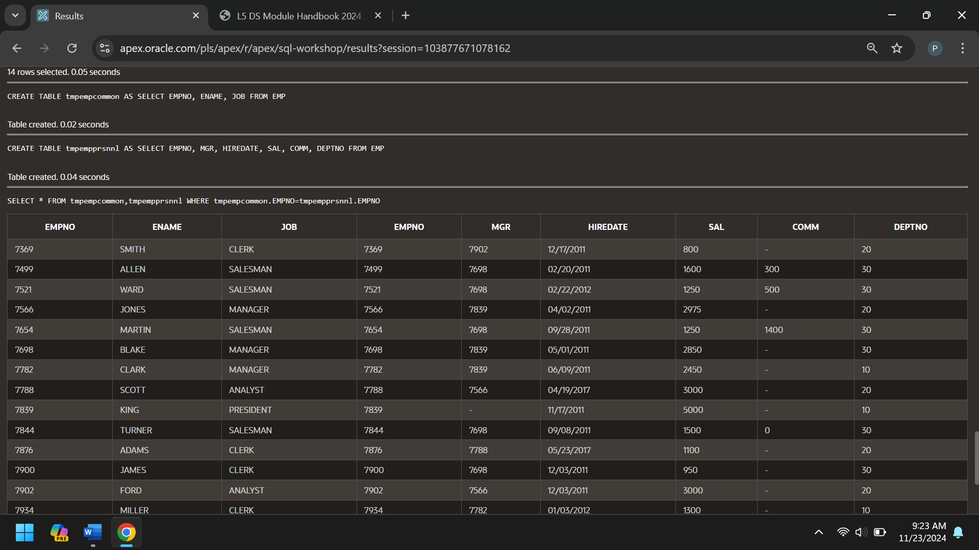
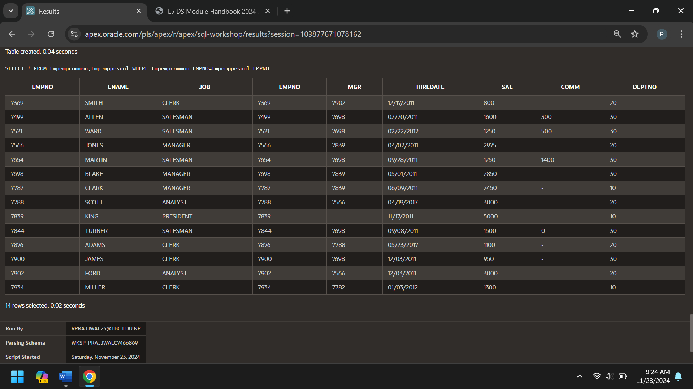
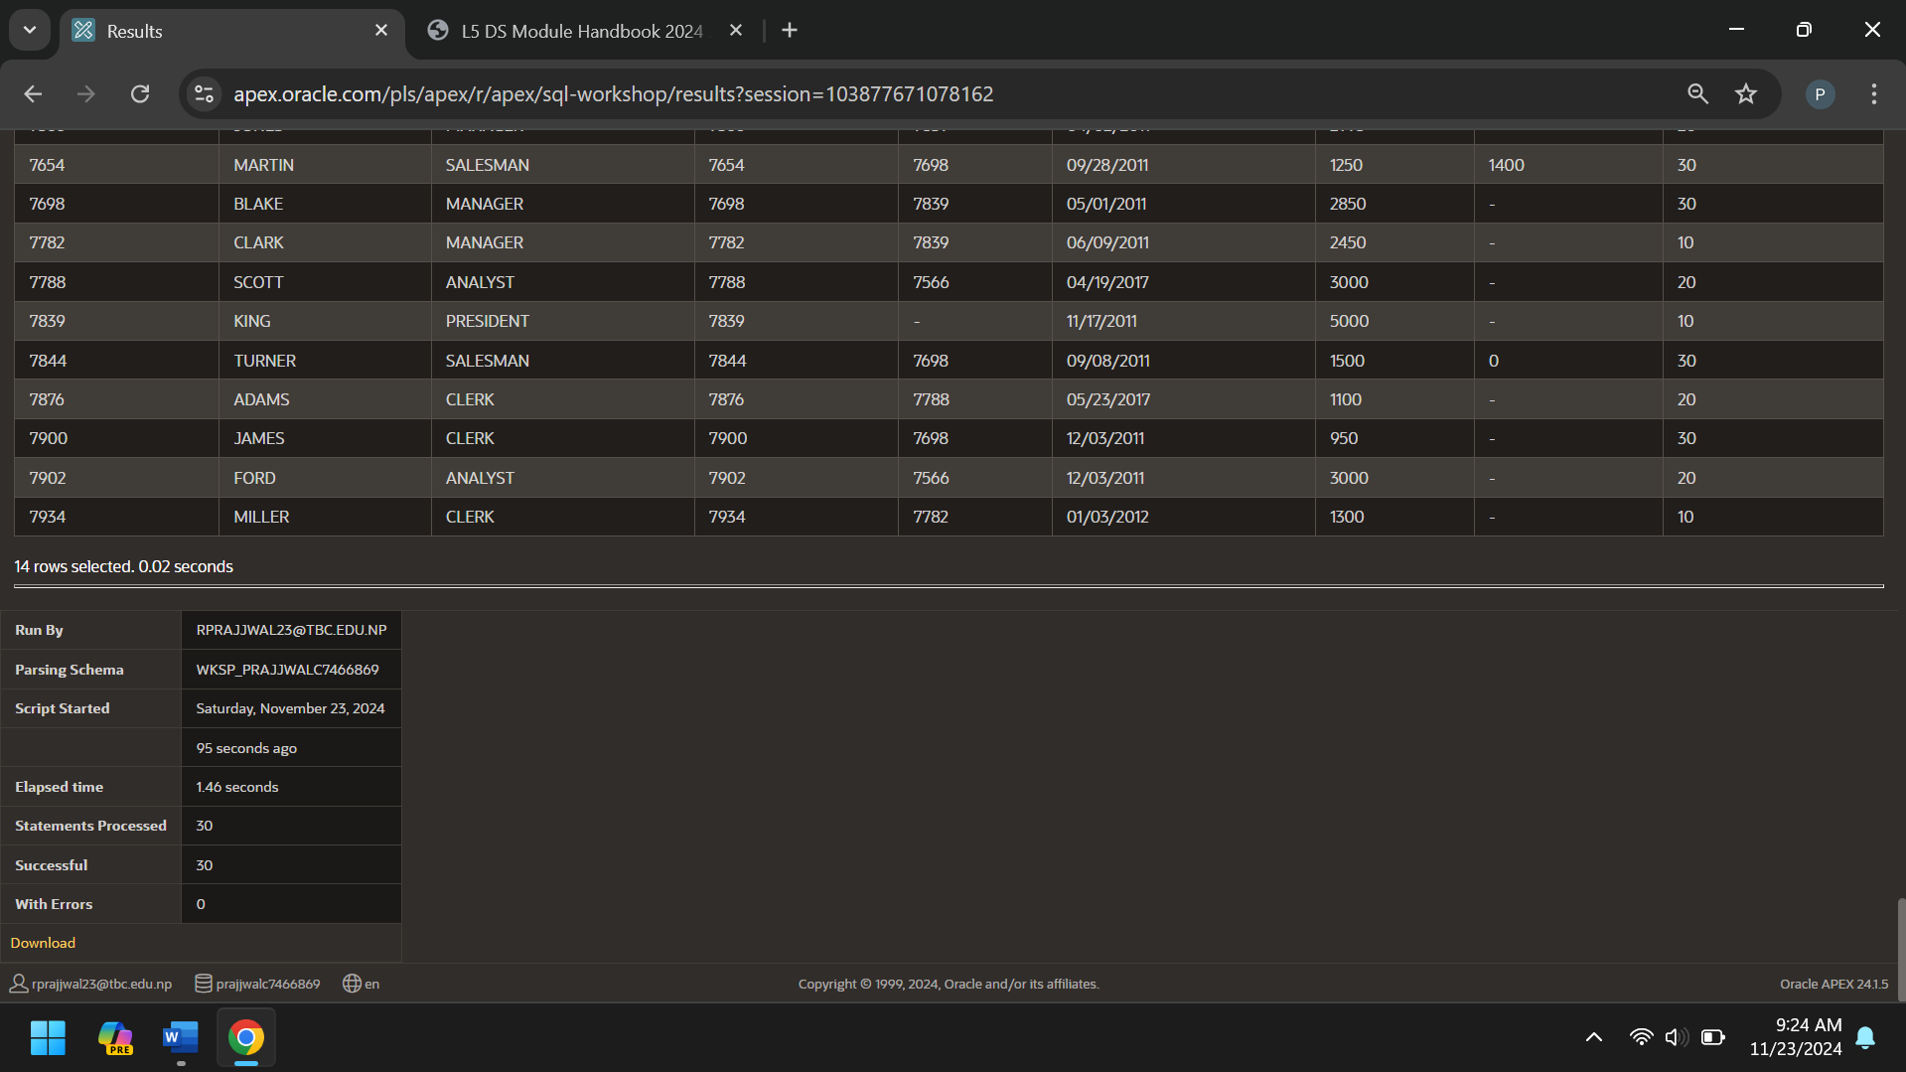

References
Geeks, G. f., n.d. geeksforgeeks. [Online]
Available at: https://www.geeksforgeeks.org/introduction-of-database-normalization/
[Accessed 23 November 2024].

Leeds Beckett University. (2024). Entity Relationship Modeling. COMP416 - Fundamentals of Databases (Module Code: 14797). Available at: https://my.leedsbeckett.ac.uk/webapps/blackboard/execute/content/file?cmd=view&content_id=_4991214_1&course_id=_166533_1 (Accessed: 24 November 2024).

thomas Connolly, C. B., n.d. Datbase Systems A Practical Approach To Design, Implementation and Management. Fourth Edition ed. s.l.:Pearson Education, Ltd..

w3schools, n.d. w3schools. [Online]
Available at: https://www.w3schools.com/sql/sql_join.asp
[Accessed 21 November 2024].

Leeds Beckett University (2024) COMP560 - Database Systems - 14800 - AUT - 202410. Available at: https://my.leedsbeckett.ac.uk/ultra/courses/_174548_1/cl/outline (Accessed: 25 November 2024).

Appendix H – Originality and Use of Generative Artificial Intelligence (GAI) Statement
I understand that to use the work and ideas of others, including generative AI output, without full acknowledgement, is academic unfair practice.
I confirm that this coursework submission is all my own, original work and that all sources, summaries, paraphrases and quotes are fully referenced as required by the LBU Academic Regulations.

DECLARATION OF GENERATIVE AI USE (This is an example, you can modify, adapt, delete as appropriate):
I did use Generative AI technology in the development, writing, or editing of this assignment. I have included a copy of the reference used, and the output generated in the Appendix section. If you have any concerns about whether you have used generative AI tools (in)correctly, please seek advice before submitting your assignment from academic staff responsible for the assessment that this submission relates to. The shaded boxes are examples to help you with completing this section.
Numbering | Generative AI Tool (e.g. ChatGPT) | How generative AI Tool was used | Reference
1 | ChatGPT 4 | in simple terms explain to me how to conduct database normalization up to the third normal form | OpenAI. (2024). ChatGPT (Feb 22 version) [Large language model]. https://chat.openai.com/chat  Output: Database normalization is a process to organize a database into a structure that reduces redundancy and improves data integrity. Here's a simple explanation of how to normalize a database up to the Third Normal Form (3NF):  Step 1: Understand the Data  - Write down all the data you need and think of it in terms of a table with columns (attributes) and rows (records).  - Identify what the data represents (e.g., customers, orders, products).  Step 2: First Normal Form (1NF)  Goal: Eliminate duplicate columns and ensure each column contains only atomic (indivisible) values.  - Ensure each cell in the table has a single value.  - Bad example: A "Phone Numbers" column containing "123-456, 789-012".  - Fix: Split into separate rows or create a separate table for phone numbers.  - Ensure each column contains values of the same type.  - Example: A "Date" column should only have dates, not names or amounts.  - Ensure the table has a unique identifier (Primary Key).  - Add a column that uniquely identifies each row, like CustomerID.  Step 3: Second Normal Form (2NF)  Goal: Eliminate partial dependency. A column should depend on the entire primary key, not just part of it.  - Start with a 1NF table.  - Remove partial dependencies:  - If the primary key is made of multiple columns, make sure all non-key columns depend on the entire primary key.  - Example: In a table where the primary key is OrderID + ProductID, if "CustomerName" only depends on OrderID, move it to a separate table.  - Create separate tables for related data and use foreign keys.  - Example: Split a single table into Orders and Products.  Step 4: Third Normal Form (3NF)  Goal: Eliminate transitive dependency. Non-key columns should depend only on the primary key, not other non-key columns.  - Start with a 2NF table.  - Remove transitive dependencies:  - Example: In a table with OrderID, CustomerID, and CustomerAddress, if CustomerAddress depends on CustomerID (not OrderID), move CustomerAddress to a separate Customers table.  Final Example  Starting Table:  1NF:  - Split multi-valued attributes (e.g., one product per row).  - Add a primary key like OrderID + ProductID.  2NF:  - Create separate tables for Products and Customers.  - Products: ProductID, ProductName.  - Customers: CustomerID, CustomerName, CustomerAddress.  3NF:  - Ensure no transitive dependencies. Move CustomerAddress to the Customers table since it depends on CustomerID.  Resulting Tables  - Orders: OrderID, CustomerID, ProductID  - Products: ProductID, ProductName  - Customers: CustomerID, CustomerName, CustomerAddress  By this point, your database is organized, redundant data is minimized, and relationships are clearly defined!  5
  OrderID | ProductID | ProductName | CustomerID | CustomerName | CustomerAddress

